CHAPTER 5: Chemical reactions
Worksheet 5.1

Chemical equations
Student: Class:

Atom and mass conservation
1. Consider the following reaction between carbon dioxide and hydrogen.
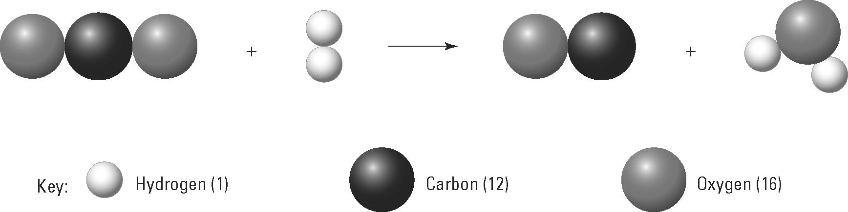
(a) Name the products of this reaction.

(b) Show that the number of atoms of each element is conserved in the reaction.

(c) Use the atomic weight data provided in the key to show that the total mass of reactants equals the total mass of products.

Balancing an equation
2. The following diagram models a chemical reaction, but the equation is not balanced.
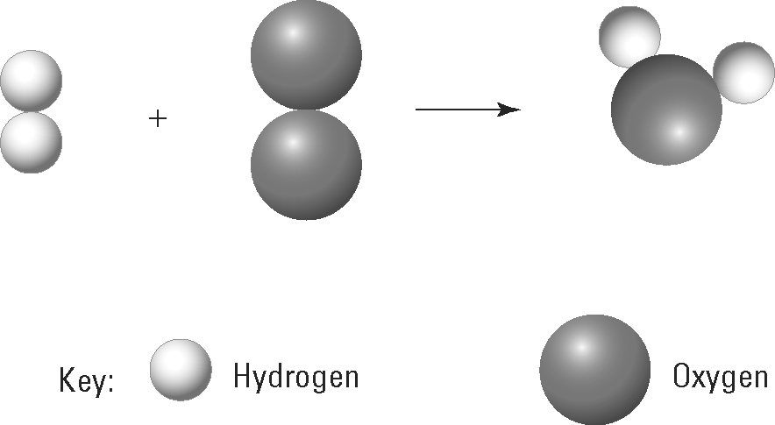
(a) Explain why this equation is not balanced.

(b) Draw in extra molecules in the diagram above to balance the equation.

